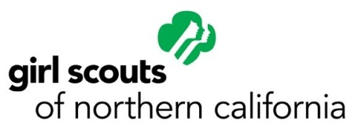
RELEASE OF LIABILITY AND ASSUMPTION OF RISK AGREEMENT
FOR ADVENTURE PROGRAMS

Name of Participant: _______________________________________________________ Date: ____________________

Event: Ropes Course

Location: € Skylark Ranch Camp, Pescadero CA € Bothin Camp, Fairfax CA

I acknowledge that there is an inherent risk of injury in the above referenced activity or event. I hereby assume full responsibility and risk of injury, death, property damage, any loss or liability, and any cost that may be incurred as a result of participation in the above referenced event or activity.

I agree to indemnify and hold harmless Girl Scouts of Northern California, its employees, representatives, and agents from any claims, actions, or liabilities (including reasonable attorney fees), for any occurrences which result in any injury, illness, accident or harm of any kind to Participant while participating in the above referenced event or activity.

I also expressly agree to release and discharge Girl Scouts of Northern California, its employees, representatives, and agents from any act or omission of negligence in rendering or failing to render any type of emergency or medical service.

In signing this document, I fully recognize and understand that I am giving up my right and participant’s right to make a claim or file a lawsuit against Girl Scouts of Northern California even if they or the event operator negligently or by some other act or omission cause injury or damage to participant.

I agree that this Release of Liability is intended to be as broad and inclusive as is permitted by the law of the State of California and that if any portion thereof is held to be invalid, the balance of the agreement shall continue in full legal force and effect.

As parent or legal guardian of a participant under 18 years of age, I voluntarily agree that said minor may participate in the above referenced event or activity, and sign this release on their behalf. I understand that this is a release of all claims that is binding on myself, my heirs, members of my family, personal representatives and assigns. I understand that I am assuming all risk inherent in the above referenced event or activity. I voluntarily sign my name as evidence of my acceptance of the above provisions.

I have read and understand this document.

________________________________________________ _________________________
SIGNATURE OF PARTICIPANT OR DATE
PARENT/LEGAL GUARDIAN IF PARTICIPANT IS UNDER 18 YEARS OF AGE

I,(translator’s name)_________________________________________,hereby warrant that I read this document for

___________________________________________because she/he does not speak/understand enough English to read this document for themselves. I further warrant that I fully and clearly explained each item on the document to the participant and that I am fluent in the language of the participant and qualified to explain the document and understand the participant’s answers, and that I clearly and unambiguously was told that she/he understands each item.

